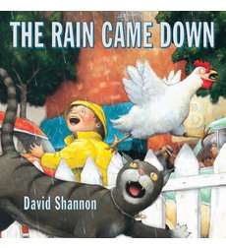
Book of the Month: “The Rain Came Down” by David Shannon
Synopsis:
Once upon a sunny day, the sky clouded over and the rain came down. The chicken squawked, the baby cried, the traffic snarled, the groceries fell, the people bickered, and still, the rain came down.
In pictures full of wit and good-natured humor, Caldecott Honor artist David Shannon captures the chaos that follows an unexpected downpour. Rain or shine, here is an engaging story that will brighten the day of all readers.
Activity | Procedure
Prior Knowledge | Invite children to share their experiences with being in the rain. Have children complete these two sentences: One thing I like about being in the rain is________. One thing I don’t like about being in the rain is________.  - What is a downpour?  - What time of the year does it rain a lot?  - What do you wear/use when it rains?
Vocabulary | Louder rainbow splashed  Still stream squawk yowled squirmed beauty parlor barber shop bickering rukus  (Remind children that words can have more than one meaning. Explain that in the book, still means keeps on happening. Ask volunteers to give other meanings (quiet, not moving)
Comprehension  Questions | - “By looking at the cover, how are the characters feeling in the story?”  - “What is causing them to react this way?”  - “How do you feel when it rains?”  - “How do you feel when it is sunny?”
Word Wall Words | Chicken ice cream traffic  painter cat dog man taxi driver
Learning Experience Activity/ Shared Writing  Early Writing dictation activity  Circle Time Literacy  Letter Recognition Activity | Book: Have the children make a book about a rainy day and the cause and effect relationships they experienced, in chronological order just like the format of the book.  Draw a rainy day: Have children draw what they see during a rainy day and dictate what is going on.  Retelling the Story:  Materials  - Sentence-strip paper  - Pocket chart  - Markers, crayons, and pencils  - Drawing paper  Activity  - Reread the book several times to familiarize the class with the text and the story sequence.  - Ask the children to recall the different events as they occurred in the story. Begin by asking them to recall what day the rain came down and what animal was the first to react.  - Record each event on a separate piece of sentence-strip paper. Refer to the book if the children need assistance.  - After all the events have been recorded, provide each child with a sentence strip, a small sheet of drawing paper, and markers, crayons, and pencils to illustrate each sentence. If there aren't enough story sentences for each child, several children can illustrate the same event.  - Attach the illustrations to each sentence strip. Mix up the order of the events and place them in a pocket chart. Read each sentence with the class, encouraging them to identify familiar words. Invite the class to organize the events in proper sequence.  - Place the book and the sequence strips in the reading area to provide children with additional opportunities to revisit the activity during small-group time or center time.  Get a shoe box and place the names of the children in the box. Chant the song: It’s raining it’s pouring the old man is snoring, he jumped in bed and bumped his head and, stop!  Have the child pull out one of the names and identify the first letter of the name, the person’s name, and then place the name tag under the same letter the name begins with on the word wall.
Print Awareness Activity | Have the children look at the front of the cover of the book…  Point out the parts of the book- - -  Cover (front of the book),  spine (side of the book),  back of the book.  Next, Point to the title and read it, then count the number of words in the title.
Phonological Awareness Activities | Fun with Alliteration- Have children take turns saying the following phrases :  Mickey Moos makes mushy moon pies on Monday.  Thundering Thaddeus tickles tinny toads on Tuesday.  Whimpering Whilda the witch waves her withering wand on Wednesday.  Thirty thick thistles wave on Thursday.  Funny Frankie fries fish on Friday.  Silly Sally sings song in the Saturday sunshine.  This nonsensical little rhyme can be adapted to work with any letter! While youngsters eat their lunch or snack, chant:  “Itsy-bitsy jibbery jee-who has food that starts with C.  Help youngsters identify the sound of the letter C and then identify any food they’re eating that begins with a C. Repeat the process, altering the rhyme as needed. For example, say, “Itsy-bitsy jibber jess, who has a food that begins with S.
Songs/ Transition Ideas | Whistling Wind added 8-7-97 Original Author Unknown  Sung to: "If you're happy and you know it"  If you hear the whistling wind,  Cup your ears.  If you hear the whistling wind,  Cup your ears.  If you hear it in the trees  Making music with the leaves,  If you hear the whistling wind,  Cup your ears.  If you feel the Blustery wind,  Whirl around  If you feel the blustery wind,  Whirl around.  If you feel it lift your hair  Like a kite up in the air,  If you feel the blustery wind,  Whirl around.  Rain Song added 8-7-97 Original Author Unknown  Sung to: "If you're happy and you know it"  First a little drop of rain hit the ground, (Tap, Tap)  Then another drop of rain hit the ground, (Tap, Tap)  Then another and another and another and another,  And pretty soon we heard a different sound. (Splash! Splash!)
Math – Counting | Materials needed  - Blue construction paper  - Scissors  - Sharpie marker  To set up puddle jump  The first thing you need to do is cut out “puddle” shapes from your blue paper. 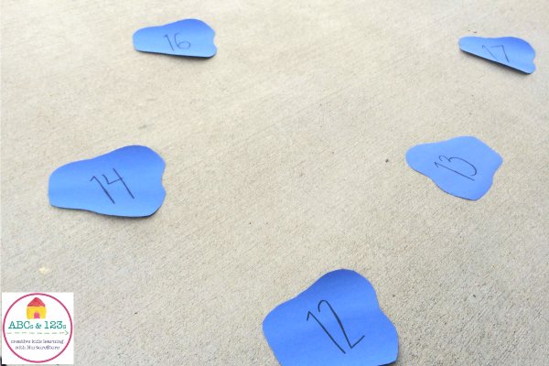  Once you have a pile of puddles (how many you need will depend on what numbers you are focusing on), write a number on each puddle.  I decided to focus on the numbers 11-20 with my kids (ages 6 and 7), but if you have younger ones you could use simply the numbers 0-5 or 1-10.  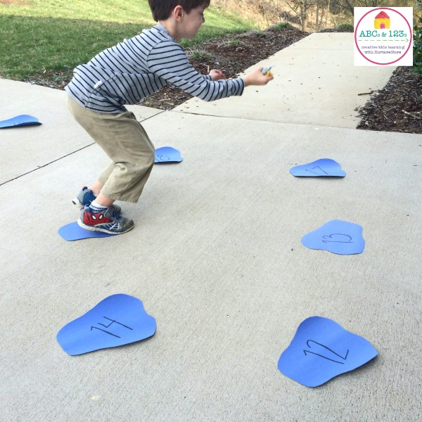  Playing puddle jump  Lay all the number puddles on the floor or ground so that there is enough room for kids to jump from number to number Also note that it may be helpful to tape the puddles down so that they do not slip or blow away (if you’re outside).  To begin, kids take turns jumping from number to number in order, starting from 11 and counting all the way to 20.  Then, they can jump back from 20 to 11, saying each number again as they count backwards.  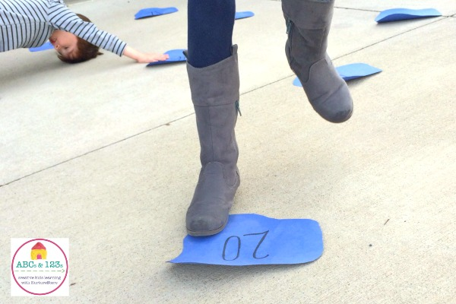  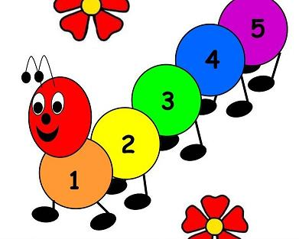  Spring Time Caterpillar Counting Game  ASSEMBLY INSTRUCTIONS: 1. Game board: Fasten the above label to the front of a file folder. Fasten pages 2 and 3 (caterpillar) on the insides of the file folder. Laminate. 2. Game pieces: Cut out the circles of flowers on page 4. Laminate. 3. To store game pieces, place them inside closed file folder. Fasten sides of folder together with paper clips or report cover spines (cut to fit), or attach Velcro inside the file folder to keep the sides closed. GAME PLAY Count the flowers on each circle. Match the circle to the section on the caterpillar with the corresponding number.  (see attached for materials)
Science/Discovery  Food Experience  Sensory Table Ideas | Exploring Rain Clouds  Talk briefly about how water vapor makes up clouds and then falls when it gets heavy.  Fill a clear plastic container with water and top it with shaving cream (the cloud). Provide the children with blue watercolor paint and pipettes.  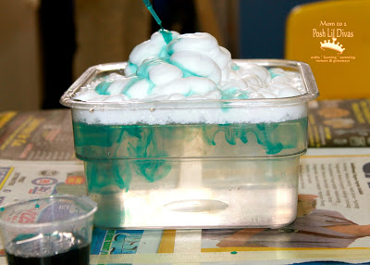  Have the children drop the blue watercolor onto the shaving cream and observe what occurs. After a few drops the watercolor drops through the shaving cream cloud, into the water and makes visible blue rain.  This experiment shows how clouds get overfilled with water.  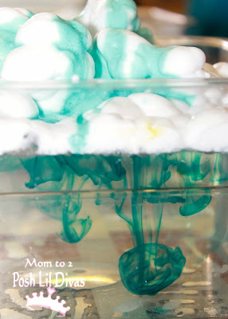  Grass Heads  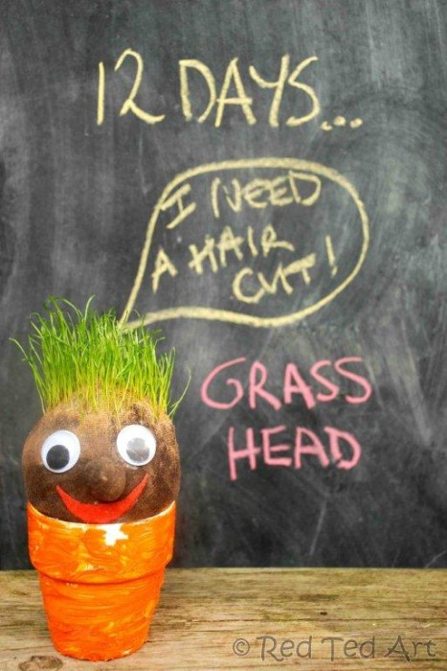  What You Need  - Old tights/stockings  - Some compost or earth  - Grass seeds  - Rubber band or thread  - Googly eyes and felt for decorating  - A pot for your grass head to sit in!  Put 2-3 table spoons of grass seeds into the bottom of your tights.  Add a lot of earth until you have a nice sized ball. Tie the bottom of the tights and shape into a ball if needed.  Pinch a “nose”; twist and wrap and tie into place.  Glue on googly eyes and a mouth  Place into a pot. Add water to the tights and the earth will soak it up.  Keep in a sunny spot and don’t water too much!  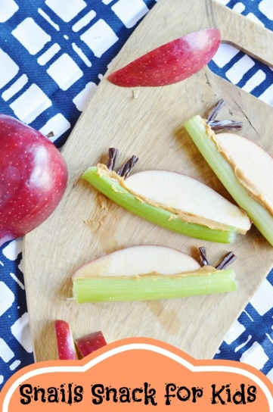  What you need  About 5 celery stalks  jar of peanut butter (or other allergy friendly option)  chocolate twizzlers  1 apple  First start by putting peanut butter in the middles of the celery stalk. You will also want to trim the stalk into 1/2 sections, then cut up the twitters. You will cut it length wise in half and cut them into smaller pieces to use the antennas.  You also want to cut the apple in half and then thinly slice the apple slices.  Now press the apple slice into the celery stalk, into the peanut butter. Then place two antennas into the peanut butter.  http://www.survivingateacherssalary.com/snail-healthy-animal-snack-for-kids/  Spring Garden Sensory Tub  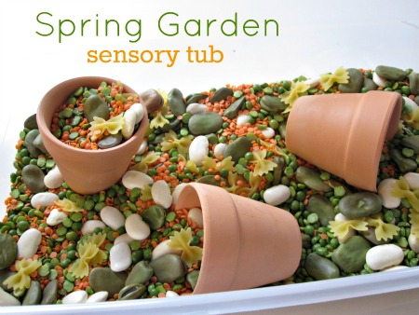  You will need  Dried split peas, large dried Lima beans, dried orange lentils, dried white beans, mini bow tie pasta and some small flower pots. You will also need a tub – this one was a dollar at Walmart.  - Start by pouring the dried beans and lentils into the tub.  - Next add a handful of butterflies (the dry bow tie pasta).  - Add flower pots and other tools like tongs to help explore.  http://www.notimeforflashcards.com/2011/03/spring-garden-sensory-tub.html
Social and Emotional | Explain cause and effect relationships.
Creative Art | Weather Sounds Umbrella  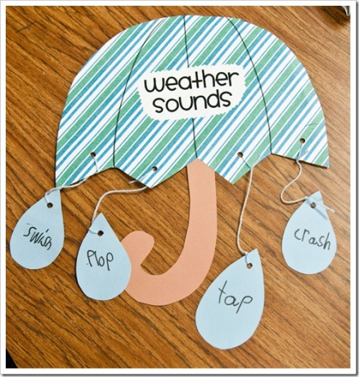  What you need:  - Scrapbook paper/cardstock (different designs so children can pick their umbrella)  - Yarn, string, pipe cleaners  - Markers  - Glue  Have the children pick out their umbrella, handle and 4-6 rain drops.  Have them come up with sounds that the ran makes when it hits the ground and assist in writing the words on the rain drops  Then have the children string their raindrops on with the yarn/string/pipe cleaners while you help to finish the assembly (knot tying)  http://thefirstgradeparade.blogspot.com/2011/03/onomatpoeia-say-it-three-times-fast.html
Dramatic Play | Retelling the Story  Activity  - Once the children have become familiar with the story they can take turns reading aloud or dramatizing the story.  - Encourage them to identify familiar words and to use the illustrations from the book to guide their storytelling.  - Invite the children to dramatize the story. Choose one child to be the narrator and other children to portray different characters in the story. Use props from the classroom to enhance the dramatization.  - Celebrate the children's accomplishments with a picnic lunch or outdoor snack! If the weather doesn't allow this — have an indoor picnic.
Book Suggestions for the Library | Other books by David Shannon:  Duck on a Bike  A Bad Case of Stripes  The Bunyans  The Amazing Christmas Extravaganza  It would pair well with Patricia Lakin’s Rainy Day!  If you want to explore the water cycle, pair it with All the Water in the World.

