Thursday, October 20, 2022
6:00-7:30
Please join us at South Woods Elementary for our Fall Festival
Bracelets are $5.00 per person (children under 2 Free) and provide access to all of the booths on the field.
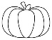Popcorn 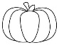 Face Painting 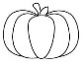Corn Toss Apple Grab
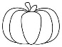 Pumpkin Ring Toss 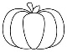 Hay Rides 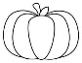Book Fair Pumpkin Bowling
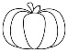 Harvest Photo Booth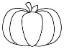 Donut Fishing 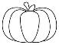KaraokeLollipop Pumpkin Pull

And, so much more!
---------------------------------------------------------------------------------------
Please return this form to your child’s teacher with cash or a check made out to SWES PTO by October 7th. Bracelets purchased after October 7th will need to be purchased at the door.

Student Name _______________________ Grade __________ Teacher ___________________
Student Name _______________________ Grade __________ Teacher ___________________
Student Name _______________________ Grade __________ Teacher ___________________
Student Name _______________________ Grade __________ Teacher____________________
Total Number of Student Bracelets Needed ________($5.00 each)
Number of Adult Bracelets Needed ____________ ($5.00 each)
Total Amount Enclosed $_______________________

