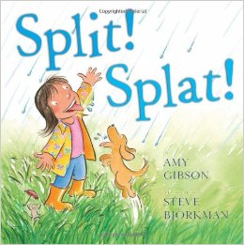
Toddler Activities
Book of the Month: Split Splat by Amy Gibson

Book Synopsis
The rhyming text of this book follows the simple joy of a young girl as she splashes with her friends in the rain. As they stomp in puddles and sploosh through mud.
The story begins inside the girl’s house as the rain begins to fall, so she puts on her rain gear and heads outside to play. As the story progresses, she flings off her hat, her boots, and her raincoat in favor of experiencing as much of the rain as possible. The girl and her dog finish the book in a bubble bath after making mud pies and having playful mud fights.
The bright pinks, greens, and blues of the watercolor illustrations evoke the freshness and joy of a spring rain and Gibson’s words have a musical quality to them. It would be fun to set the text to a simple tune and to sing it during story time.
The simple plot line and liberal use of onomatopoeias make this a great candidate for a preschool story time about spring or weather.

Circle Time
Before reading the story, talk about how April showers bring May flowers and other things we see in the Spring.

Pocket Chart
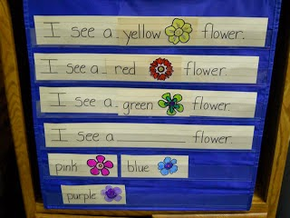
You can create a pocket chart for practicing the concept of color words and sing a song about Spring time and what we typically see in the Spring.
Songs
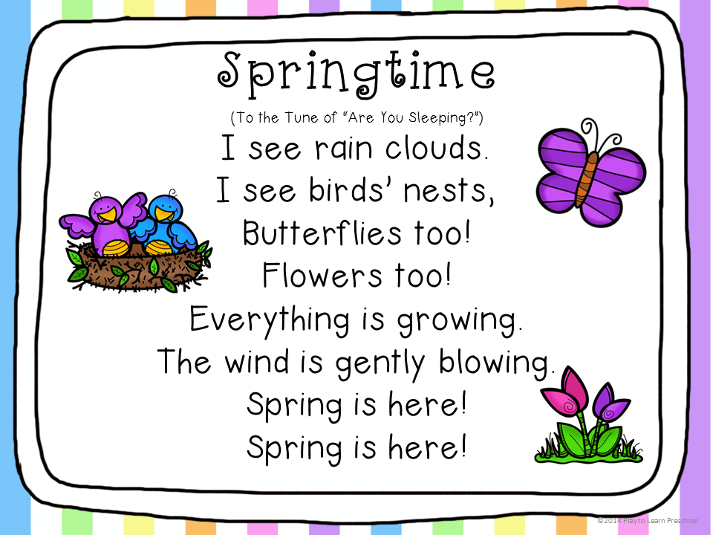

Pitter Patter Rain Song:
Pitter patter, pitter patter,
Listen to the rain!
Pitter patter, pitter patter,
On the window pane.
Dropping, dropping, dropping, dropping,
Dropping on the ground.
Dripping, dripping, dripping, dripping,
Listen to the sound!

Spring Surprise bag!
Materials Needed: paper bag or basket and pictures of spring items. Some suggestions are:
- flowers
- A baby bird/chick
- Caterpillars & Butterflies
- Eggs
- Bugs
- Bunnies
Use this activity to introduce springtime.
Explain the above items are all things we see and experience in spring.
5 Little Ducks Finger Play
Five little ducks went out one day
Over the hill and far away
Mother Duck said ‘Quack, Quack, Quack, Quack’
And only four little ducks came back.
Four little ducks went out one day…..
(and so on until)
…And none of the five little ducks came back.
So sad Mother Duck went out one day
Over the hill and far away
Mother Duck said ‘QUACK, QUACK, QUACK, QUACK, QUACK, QUACK, QUACK’
And all of her five little ducks came back.
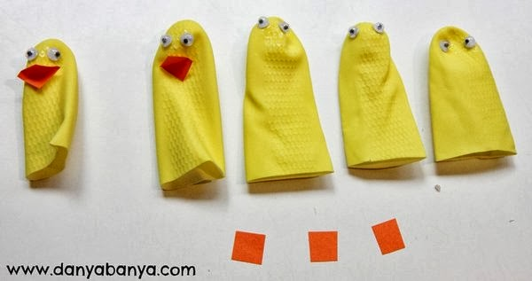(Yellow rubber washing up gloves)

Art
Windsocks
What you need:
Oak Tag/Poster Board/ Card Stock – (you need heavy type paper or even an oatmeal carton would work well)
Paint/markers - for decorating
crepe paper - choice colors
stapler
glue
scissors
hole puncher
yarn/string
1. Cut paper into size you want for windsock and have child decorate

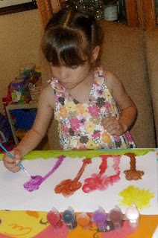

2. Turn it over and glue on the strips of crepe paper (cut into even strips - just cut to desired length)
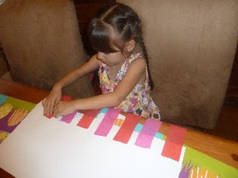

3. Staple paper into a cylinder shape and hole punch two holes in the top to attach the yarn to

4. Take your finished windsocks outside to fly in the wind!

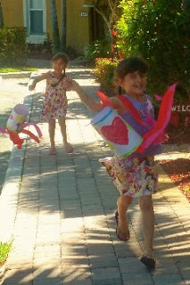
http://www.momto2poshlildivas.com/2013/04/exploring-spring-weather-with-kids.html
Lower case “r” craft

In the spirit of April showers bringing May flowers, here is a cute craft using the letter “r”.
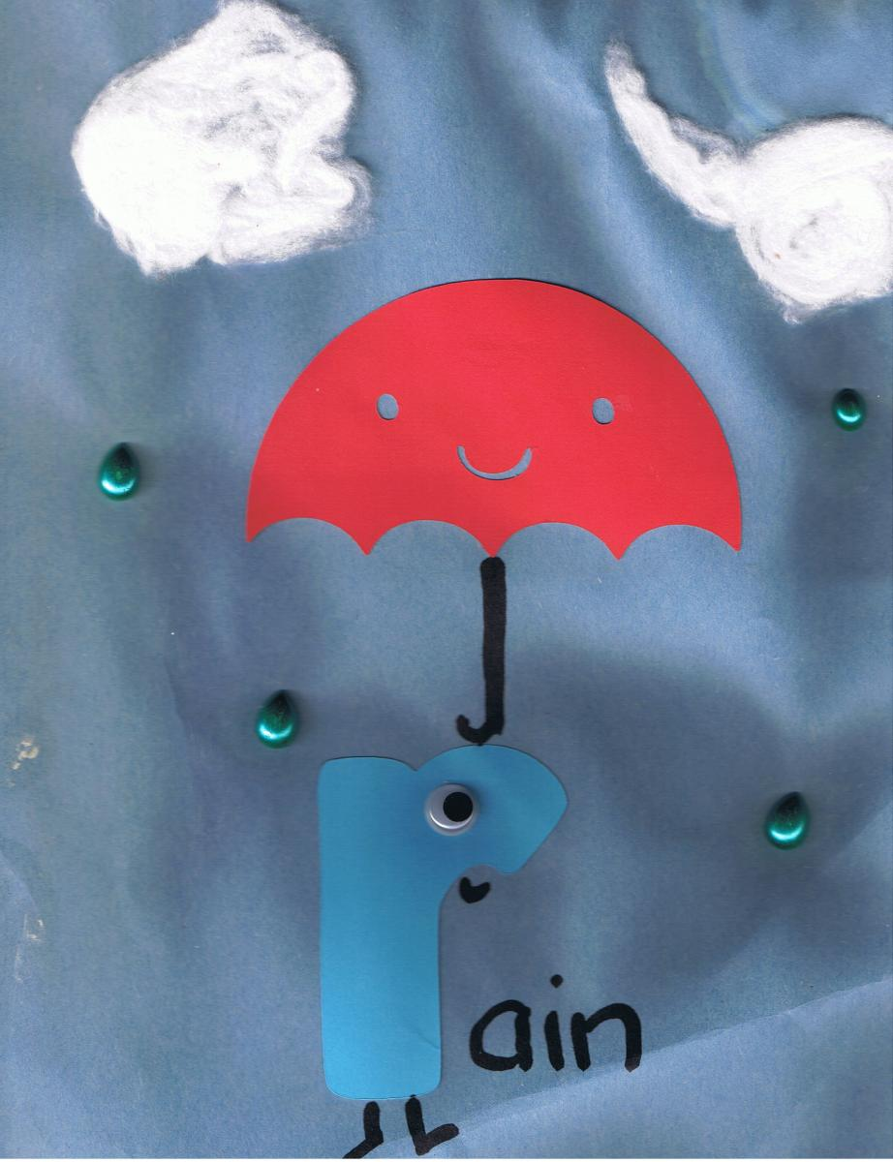http://burlington.momstown.ca/2014/03/19/preschool-letter-r-craft-r-rain/
Allow the children to help glue the cotton ball clouds and the umbrella on, along with squeezing the raindrop onto the paper.
Dramatic Play
DIY Garden for Pretend Play

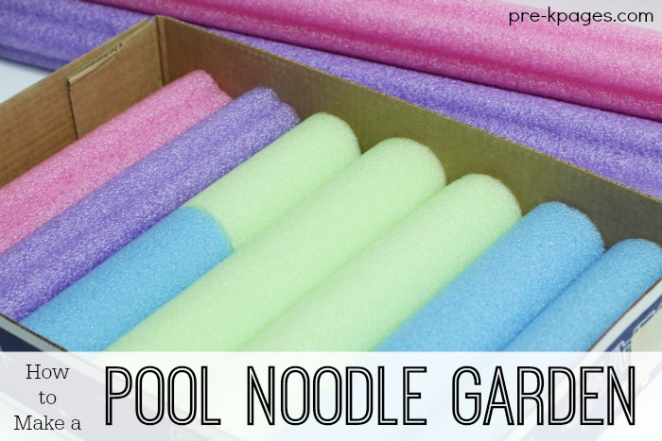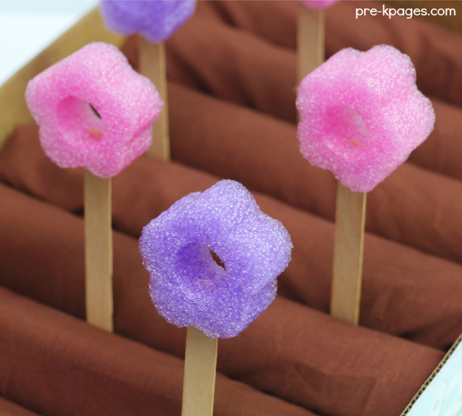
- First, find the lid of a copy paper box.
- Next, use the packing tape to attach the picket fence bulletin board border around the outside edges of the box.
- Then, measure the dimensions of the box.
- Now, measure your pool noodles and use the bread knife to cut them to fit inside the box.
- Next, you’re ready to glue the pool noodles in the bottom of the box.
- After the pool noodles have been glued to the bottom of the box, lay the brown fabric over the top and tuck it in on the sides and in between the noodles.

- These flowers are super easy to make too! Just use your bread knife to slice off pieces of the pool noodle.
- Then, use your sharp knife to cut a slit in the bottom of each flower- the same size as a craft stick.
- Next, insert a craft stick into the bottom of each “flower” and then “plant” in your garden!

Playdough Garden Play
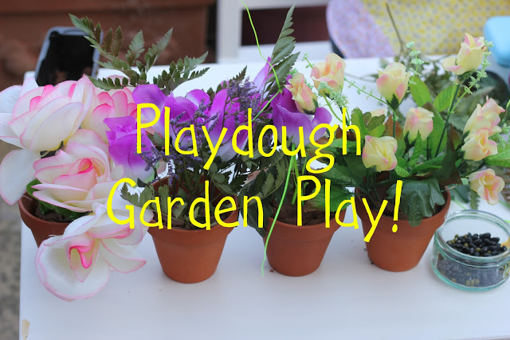
What skills will be learned?
- literacy: role-play reading and writing, language development
- maths: counting seeds and flowers, patterning, exploring capacity through filling and emptying
- physical: fine motor development through rolling/ squashing/ pinching/ squeezing play dough
- knowledge and understanding of the world: talking about garden centres, flowers, seeds, growing, life cycles, plants, selling, money etc
- creativity: imaginative play, taking on a role/ character and remaining in it during play
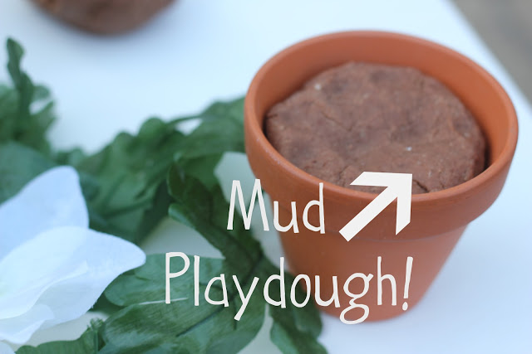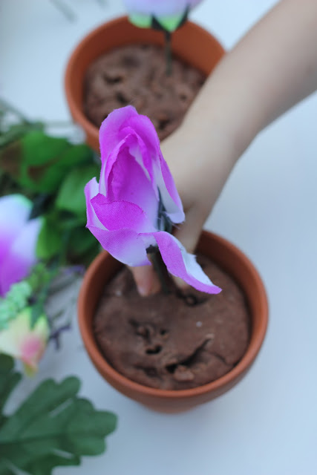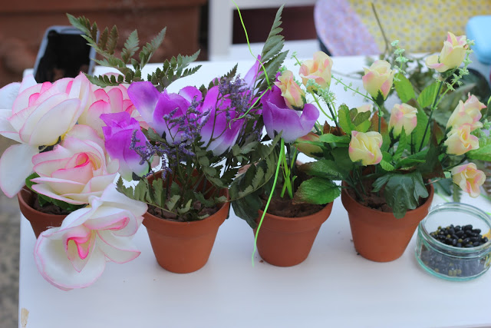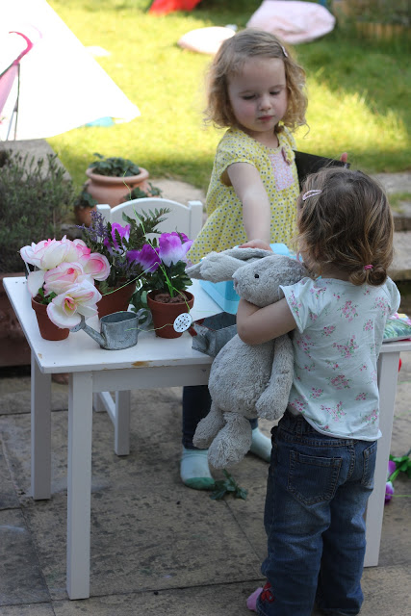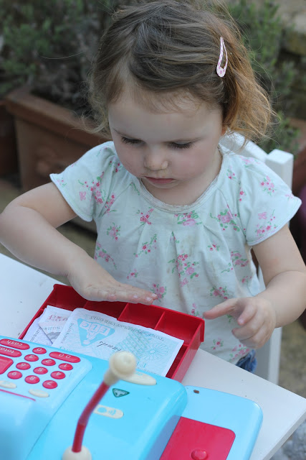
Play-dough mud Recipe:
- 2 cups plain flour (all purpose)
- 1 cup salt
- 1/2 cup cocoa powder
- 2 tbsps vegetable oil
- 2 tbsps cream of tartar
- 2 cups of boiling water
- 4 drops of glycerine (optional extra for increased shine and stretch)
Method:
- Combine all of the dry ingredients in a bowl
- Stir in the vegetable oil
- Mix together
- Stir in the boiling water (adult only) and mix until combined
- When it has cooled a little, knead it on a clean surface until it loses all stickiness and becomes smooth and stretchy. No residue should come off on your fingers. If it is still sticky add a little more flour, if too dry and crumbly add more water, a tablespoon at a time.
Gross Motor
Use carpet squares or tape puddle shapes to the floor and let the kids puddle jump. You can even put on some lively music! Whatever material you use to make your puddles, just make sure it’s not slippery.
Music and Movement
Splashing in the Puddles
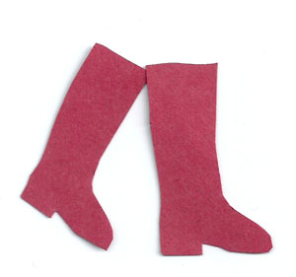
Splashing in the puddles, (stamp around the room)
Splashing in the puddles, (stamp around the room)
Splashing in the puddles, (stamp around the room)
But don’t let Mummy see! (finger to lips like a secret)
*
Walking through the raindrops, (hold umbrellas overhead)
Walking through the raindrops, (hold umbrellas overhead)
Walking through the raindrops, (hold umbrellas overhead)
Let’s hope we don’t get wet! (wag one finger)
Stamping in the gutters, (stamp along in a line)
Stamping in the gutters, (stamp along in a line)
Stamping in the gutters, (stamp along in a line)
But don’t let Mummy see! (finger to lips like a secret)
You tube video: https://youtu.be/S79L7k_khj0

The Umbrella Song
Down come the rain drops SPLASH, SPLASH, SPLASH! (stamp feet on the splashes)
Let’s run for cover, DASH, DASH, DASH! (run on the spot)
Pitter patter, pitter patter, DRIP, DRIP, DROP! (clap hands in rhythm)
I’m under my umbrella till the raindrops STOP! (put up pretend umbrella)
You tube video: https://youtu.be/tGiAd5sDpUs
http://www.letsplaykidsmusic.com/rainy-day-nursery-rhymes/

