South Woods Elementary School Extended Day Program 2020-2021

Registration & Rates
There is a non-refundable registration fee of $40.00 per child per school year. The annual registration fee is required for both new and returning students.
AM before school care per child is $3.00 per day = $30.00 for 2 weeks
PM after school care per child is $12.00 per day = $120.00 for 2 weeks
AM/PM school care together is $15.00 per day = 150.00 for 2 weeks
LATE PICK UP CHARGES
A charge of $1.00 per minute, per child will be charged for late pick up…NO EXCEPTIONS. Secure back-up arrangements with family, friends or neighbors for emergencies. This is a St. Johns County School District policy strictly enforced.
PAYMENT PROCEDURES
All checks are to be made out to South Woods Extended Day, please put your child’s name on the memo line.
Payments are due every second Friday of the month (2 weeks) by end of business day.
You are required to pay on time regardless of whether you have or have not seen a statement. Any questions regarding your statement should be addressed prior to the due date.
Please make sure we have your email and contact info, you will be emailed statements bi-weekly.
DO NOT include payments for other school services/functions in your Extended Day Program payment.
The State of Florida requires us to collect the registration fee + 2 weeks in advance. Parents can make payments through www.schoolpay.com. It’s quick, easy and convenient. Be sure to select EXTENDED DAY. Payments can also be made in the office with cash or check.
PICK UP & DROP OFF
Mornings: Enter through the parent pick up loop, an Extended Day staff member will greet & welcome your child.
Afternoon: Enter the front office with your ID and identify yourself. Extended Day staff will call your child to the front office. Parents, if you send a person into the office to retrieve your child who is not on your approved list you MUST notify the office 904-547-8610 before dismissal. Extended Day Staff will not release your child without approval.
Early Withdrawal Policy
In the event of early withdrawal from the Extended Day Program, all registrations paid are non-refundable.
If there is a debt, the debt must be paid in full before the student is able to re-enroll.
If you should decide to re-enroll your child in the Extended Day Program after your child’s withdrawal, a registration fee of $40.00 will be required before your child can start.
Snack
Snacks will be provided for each student. Each student will be given a snack & a drink each day. If your child has allergies, please send a written note in order for accommodations’ to be made. Your child may bring their own snack and drink.

Behavior Expectations – Please discuss with your child/children.
Participation in the South Woods Elementary Before & After School Extended Day Program is a privilege.
We believe in the practice of positive reinforcement. This method encourages our students to seek positive attention rather than negative attention. You will be notified in writing of any behavior problems with your child. You, meaning the parent will be asked to sign the written notice. You can obtain a copy upon request.
One written notice, the child will be given an informal warning.
After two written notices, the child will be suspended for (1) day from attending Extended Day (before & after).
After three written notices, the child will be suspended for (3) days from attending Extended Day (before & after).
If your child receives a fourth written notice any point during the school year, he or she will not be permitted to return to Extended Day (before & after).
The Extended Day Program reserves the right to suspend and/or expel a child if at any point in time he/she threatens the safety of himself/herself or another child.
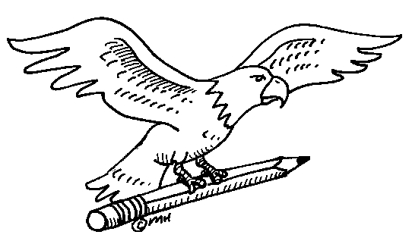

Movie Permission
Do you give permission for your child to watch “G” or “PG” movies at Extended Day in the event of inclement weather or as a reward? This will act as a movie permission slip for the school year.
YES: ___________________ NO: _____________________
Parent Signature: ________________________________

