School Spirit T-Shirts

Youth Sizes Sm-XL $12.00
Adult Sizes Sm-XL $15.00
Adult Sizes XXL-3XL $18.00

Youth Sizes
Small Medium Large X-Large Total $

Adult Sizes
Small Medium Large X-Large 2XL 3XL Total $

Student’s Name:

Teacher’s Name:

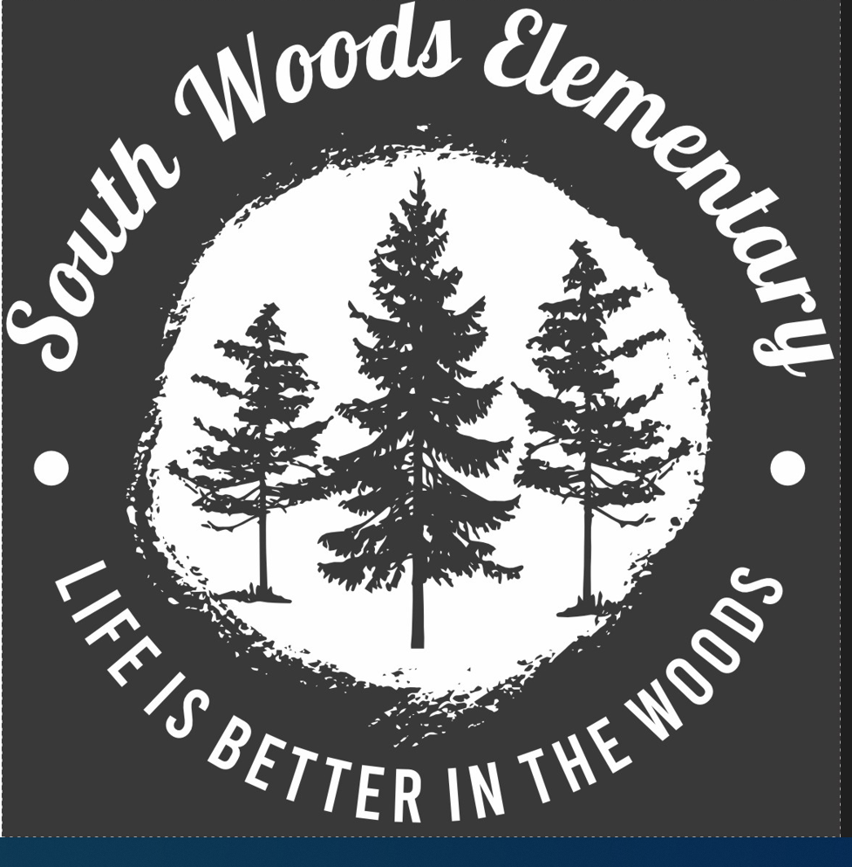

*We will accept cash or check payments, make checks payable to SWES*

